prew2/19/2021 Re-Examination-UID English Class, 19 February, 17:00-19:00 2021: Attempt review
Dashboard / My courses / UID (2020/2021 - D. Gorgan) / General / Re-Examination-UID English Class, 19 February, 17:00-19:00 2021
Started on Friday, 19 February 2021, 5:00 PM
State Finished
Completed on Friday, 19 February 2021, 6:30 PM
Time taken 1 hour 29 mins
Grade Not yet graded
https://moodle3.cs.utcluj.ro/mod/quiz/review.php?attempt=63565&cmid=22729 1/13
2/19/2021 Re-Examination-UID English Class, 19 February, 17:00-19:00 2021: Attempt review
Question 1 Complete
Marked out of 5.00
Exemplify and explain the extension of some usability heuristics in order to discover and identify detailed usability problems. Exemplify the heuristic: Match Between System and Real World, for application GUI: controlling the movement of an avatar within a video game.
Heuristics are used to find usability problems within an application. There are 10 Usability Heuristics, introduced by Jacob Nielson. An evaluator assesses an User Interface against some questions in order to make sure the design fulfils all the desired criteria.
The Match between system and the Real World heuristic concerns with the real world conventions and real world user language which are used in a Graphical User Interface. The phrases used should be easily perceived by the end user. The system should speak the user's language, using familiar concepts and not technical, niche terms. The information should be presented in a natural manner, following logical, reality-like flows. The user interaction is a key point in the product's success.
In the case of an avatar's movement in a video game, we must introduce additional explanations and questions to the heuristic in order to help the evaluators focus on the important aspects and elements. The evaluators will need to check each of the questions individually and give a mark (percentage) for the assessed heuristic, in order to identify flaws and their possible solutions.
The heuristic could be extended with questions such as: - Does the avatar move in a real-life manner?
- Does the movement resemble the one from other games? - Are the movement notions (directions, jumps) familiar to the users? - Is the movement realistic?
- Does the avatar look human-like?
- Are there any uncertainties in the movement?
For our example, there are several ways in which the user's presence can be portrayed in a game: he could be represented as a first person (a hand, a gun, etc) or a third person (a full body avatar). In the third person case, the user can see the scene from above or from "behind" the avatar, or he could switch between first and third person mode). The user's presence can be controlled by keys, mouse, joysticks, trackpads or VR kits. If the controls are chosen poorly, the user's presence may feel unrealistic or the user may have trouble navigating the scene. The avatar navigation should be intuitive, such as: - go forward: W/Up/Left click/Push joystick to front
- go backward: S/Down/Right click/Push joystick back
- go left: A/Left/Move with mouse to left
-Jump: double click/space/press joystick
- Scroll: zoom in/out
Possible issues:
- In case the user is given different controls, he may be confused since they are not the controls used in other games and therefore are not familiar.
- If the movement notions are different from reality, the user may be confused: eg. use "move avatar by fast to forward" instead of "go ahead" - The character moves unnaturally. This may cause glitches or unnatural perception of the surroundings.
q1.jpg
https://moodle3.cs.utcluj.ro/mod/quiz/review.php?attempt=63565&cmid=22729 2/13
2/19/2021 Re-Examination-UID English Class, 19 February, 17:00-19:00 2021: Attempt review
Question 2
Correct
Mark 1.00 out of 1.00
Question 3
Correct
Mark 1.00 out of 1.00
The following interaction technique is a gesture:
Select one or more:
a. combo box
b. click 
c. drag and drop
d. drag 
Your answer is correct.
What are the main usability attributes?
Select one or more:
a. Flexibility
b. Memorability 
c. Intelligence
d. Learnability 
Your answer is correct.
https://moodle3.cs.utcluj.ro/mod/quiz/review.php?attempt=63565&cmid=22729 3/13
2/19/2021 Re-Examination-UID English Class, 19 February, 17:00-19:00 2021: Attempt review
Question 4 Complete
Marked out of 5.00
Exemplify and explain the Usability Design Process presented in the figure for the Visibility and Structure usability principles, in the GUI of a 3D Graphical Editor. Detail each phase and highlight the main issues of such designing approach.

The presented design process is iterative, and it consists of four phases (check list, features, solutions and specifications). In each phase of the Design Process, the Visibility and Structure principles need to be kept in mind. We must analyze each phase and check if the principles are respected.
The explanations will be given in the context of a 3D graphical editor, such as Blender.
Visibility means that all information necessary for a user to complete a task must be visible. The user must be in control of the execution and be informed of the state of his actions without being distracted with redundant information.
Structure means the information needs to be grouped into related categories. The GUI must be organized in meaningful, useful manner. The similar controls are grouped together (eg. drop-downs) and the unrelated things are separated 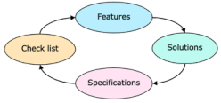in different components/parts of the application.
In the Check list phase, we analyze the two usability principles and state their attributes.
- structure: controls must be grouped together based on category; redundant information is hidden
- visibility: user is informed of the state of the desired operation; forms are validated and desired inputs are displayed
In the features phase, we think of the features we need to obtain to fulfill the checklist.
- dropdown menus
- validation messages
In the solutions phase, we provide solutions for achieving the features and analyze them, drawing conclusions on which solution is the best.
I have attached 2 solutions in the following attachment. Solution 1 describes an interface with bottom menus, separated in categories. Each category has a corresponding dropdown menu on its own, containing related information (eg: texture and texture type). On clicking something from the submenu (eg texture type), the user is presented with a prompt with the texture precision. They input the precision, the input is validated and an error message is displayed in case the input is out of range. If the input is correct, a snack-bar appears indicating the success of the operation to the user.
Solution 2 has a side menu with pictograms. On clicking a pictogram, the user is prompted with a dropdown with the desired information (textures) and on clicking a texture, they are prompted with a slider for the precision. The slider input does not need validation since it is already in a valid range. The success of the operation is displayed in the bottom terminal.
Comparing the solutions, we see that solution 1 is more clear and structured than solution 2 since it does not have ambiguous pictograms.
https://moodle3.cs.utcluj.ro/mod/quiz/review.php?attempt=63565&cmid=22729 4/13
2/19/2021 Re-Examination-UID English Class, 19 February, 17:00-19:00 2021: Attempt review
Question 5
Correct
Mark 1.00 out of 1.00
Question 6
Correct
Mark 1.00 out of 1.00
Question 7
Correct
Mark 1.00 out of 1.00
It also is more intuitive in order to find the desired texture faster. The solution 2 though has the advantage of having sliders, which avoid malicious inputs.
In the specifications phase, with the solutions we got from the solutions phase, we provide clear specifications with we check if we have achieved the check list.
After choosing the first solution, we elaborate specifications based on it: - application has a menu with words on the bottom part of the screen - clicking a menu element prompts dropdown with details - dropdown items are detailed in pop-ups
DesignProcess.pdf
The Formative Evaluation of the usability that check the correctness of the tasks on the low fidelity prototype is:
Select one:
a. Model based evaluation
b. Cognitive walkthrough 
c. Review based evaluation
d. Heuristic evaluation
Your answer is correct.
What are the main purposes of the prototyping?
Select one or more:
a. Communication approach 
b. Data model development
c. Developing the application code
d. Solution domain exploration approach 
Your answer is correct.
The Input Communication concept could be:
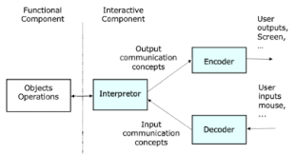
Select one or more:
a. Information to increment five values from Decoder
b. Information to invoke a command received from Decoder  c. Information to gather five values from Decoder 
d. Information to rename two objects in Decoder
Your answer is correct.
https://moodle3.cs.utcluj.ro/mod/quiz/review.php?attempt=63565&cmid=22729 5/13
2/19/2021 Re-Examination-UID English Class, 19 February, 17:00-19:00 2021: Attempt review
Question 8
Correct
Mark 1.00 out of 1.00
Question 9
Correct
Mark 1.00 out of 1.00
Question 10 Correct
Mark 1.00 out of 1.00
The syntactical form of the user command in the figure specifies through an explicit manner the following Input Communication concept:
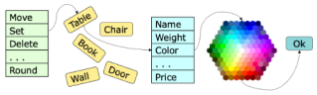
Select one:
a. Invocation information 
b. Command termination information
c. Input gathering information
d. Command execution information
Your answer is correct.
The following element could be a part of the graphical user interaction metaphor:
Select one or more:
a. Visual presentation 
b. Goal hierarchical decomposition
c. Sequence of user actions 
d. Task analysis
Your answer is correct.
What data gathering technique could be directed to a consensus view and could highlight areas of conflict?
Select one:
a. Naturalistic observation
b. Group interview 
c. Individual interview
d. Questionnaires
Your answer is correct.
https://moodle3.cs.utcluj.ro/mod/quiz/review.php?attempt=63565&cmid=22729 6/13
2/19/2021 Re-Examination-UID English Class, 19 February, 17:00-19:00 2021: Attempt review
Question 11 Correct
Mark 1.00 out of 1.00
Question 12 Correct
Mark 1.00 out of 1.00
Question 13 Correct
Mark 1.00 out of 1.00
The event oriented flow control sequence throughout the following architecture is:
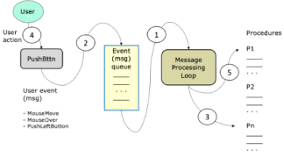
Select one:
a. 4, 2, 5, 1, 3
b. 3, 5, 1, 4, 2
c. 4, 2, 1, 5, 3 
d. 1, 2, 3, 4, 5
Your answer is correct.
Fitts's Law based evaluation provides the following:
Select one or more:
a. Evaluate the communication between the functional and the interactive components
b. The evaluation of the graphical user interface semantics c. Compare two graphical user interface solutions 
d. Evaluation of the movement of the cursor throughout the screen space 
Your answer is correct.
The Message output communication model has the following features:
Select one or more:
a. Avoid unuseful displays 
b. Transmit the changes to the presenters 
c. Require a continue communication connection
d. Describe the message based language
Your answer is correct.
https://moodle3.cs.utcluj.ro/mod/quiz/review.php?attempt=63565&cmid=22729 7/13
2/19/2021 Re-Examination-UID English Class, 19 February, 17:00-19:00 2021: Attempt review
Question 14 Correct
Mark 1.00 out of 1.00
Question 15 Correct
Mark 1.00 out of 1.00
The following Software Development Methodology has the following features:
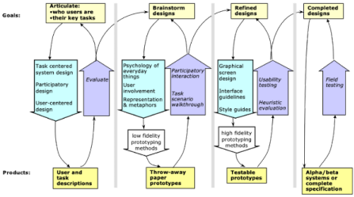
Select one or more:
a. Based on GUI prototyping 
b. It requires a very consistent technical documentation c. It requires task formal description
d. Ii is a user involvement methodology 
Your answer is correct.
Dialogue Transaction Model concept concerns with:
Select one or more:
a. Syntactical level of the interaction language 
b. Physical level of the interaction language
c. Psychological level of the interaction language
d. Semantical level of the interaction language 
Your answer is correct.
https://moodle3.cs.utcluj.ro/mod/quiz/review.php?attempt=63565&cmid=22729 8/13
2/19/2021 Re-Examination-UID English Class, 19 February, 17:00-19:00 2021: Attempt review
Question 16 Complete
Marked out of 5.00
Question 17 Correct
Mark 1.00 out of 1.00
Exemplify and explain the rol of the Recognisers and Commands modules in the Graphical User Interfaces. Give examples of 3D Graphics editing.
The picture below shows how recognisers and commands affect the input communication.
An event happens in the Interactive Component (triggered by the user interaction), which introduces an input by using the input communication concepts.
For example, the user can trigger an event through gestures or voice, and the Recognisers have the job to recognize and identify the event and attribute it to a certain command, understandable for the system. In contrast, the command module has the purpose of storing some predefined commands (such as SET, CHANGE, ADD, UPDATE, SAVE) which are the associated to procedures to be done in the functional component.
Therefore, the functional component will be fed with commands that come from the interactive component, but in a system readable and understandable form.
For example, in the case of a 3D graphics editor, the UI must gather information for a user event to perform operations on a 3D object. Suppose we have a cube. The system could have a voice recognised command for zooming into the cube, such as:
"Zoom into selected object with 15%".
The recognizers must recognize the action (zoom in) and its parameters (cube, 15%),
Command associated: ZOOM
Functional component: receives the command, and then executes the operation.
In conclusion, recognizers and commands are part of the interactive component and they
- decode user inputs
- transform input into an available form of an operation - send inputs to the functional component
Recognisers.pdf
The following figure describe the concept of:
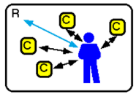
Select one:
a. Virtual Reality User Interface (VRUI)
b. Ubiquitus Computer User Interface (UCUI) 
c. Augmented Reality User Interface (ARUI)
d. Graphical User Interface (GUI)
Your answer is correct.
https://moodle3.cs.utcluj.ro/mod/quiz/review.php?attempt=63565&cmid=22729 9/13
2/19/2021 Re-Examination-UID English Class, 19 February, 17:00-19:00 2021: Attempt review
Question 18 Correct
Mark 1.00 out of 1.00
Question 19 Correct
Mark 1.00 out of 1.00
Dialogue Independence concept concerns with:
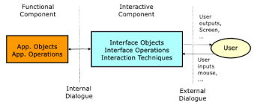
Select one or more:
a. Support the independent development of interaction techniques and interface operations
b. Separate the functional and interactive components 
c. Support the independent development of interaction techniques and functionality components 
d. Support the independent development of application objects and application operations
Your answer is correct.
The following schema describes:
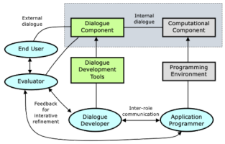
Select one or more:
a. User Interface Management Systems methodology 
b. Dialogue Independence based software
development methodology 
c. Voice based internal dialogue within a software team
d. Evaluation methodology of the software development team members
Your answer is correct.
https://moodle3.cs.utcluj.ro/mod/quiz/review.php?attempt=63565&cmid=22729 10/13
2/19/2021 Re-Examination-UID English Class, 19 February, 17:00-19:00 2021: Attempt review
Question 20 Correct
Mark 1.00 out of 1.00
Question 21 Correct
Mark 1.00 out of 1.00
The figure describes the prototyping approach by:
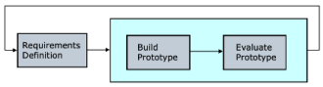
Select one:
a. Revolutionary prototyping
b. Vertical prototyping
c. Evolutionary prototyping 
d. Incremental prototyping
Your answer is correct.
In which phase of the WebQEM method is weighted the importance of elementary preferences?
Select one:
a. Define and specify quality requirements
b. Elementary evaluation
c. Global evaluation 
d. Analysis and documentation of results, conclusions and recommendations
Your answer is correct.
https://moodle3.cs.utcluj.ro/mod/quiz/review.php?attempt=63565&cmid=22729 11/13
2/19/2021 Re-Examination-UID English Class, 19 February, 17:00-19:00 2021: Attempt review
Question 22 Complete
Marked out of 5.00
Exemplify and explain the User Interface Management System methodology in the development of a game. Detail the roles of dialogue developer and programmer, and highlight the main issues of such designing approach.
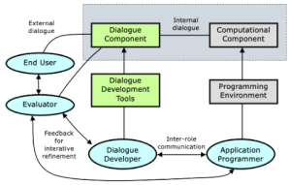
The User Interface Management System (UIMS) methodology is a mechanism which allows us to separate GUI code from processor business logic in an application. In this way, the separation increases the ease of maintainability and adaptability of the system, since the parts can be maintained and changed independently of one another. It supports N-tier architectures by defining and enforcing the boundaries between the tiers.
Multiple UIMS systems cannot be used simultaneously, therefore it is important to choose the correct UIMS model for the game development(eg. web based front-end application or standalone mobile app, which platform you want to develop on - Mac, Ubuntu or mobile).
The programmer is the person responsible for the functional component of the system (the operations performed in the back end), while the Dialogue Developer is responsible with the User Interface and transferring the necessary information to the Back-End. The two roles must communicate strongly in order to be concordance between what they implement. Every GUI action must have a corresponding functional operation.
The game development process must begin with a planning stage, where the Dialogue Developer and the Programmer are present in order to acknowledge the main architecture of the system. In this stage, brainstorming is done in order to think how to put the main ideas into features. Artists, writers, designers, developers and programmers collaborate in order to find out where each piece of the game fits.
The main issue of such an approach would be the fact that Dialogue developers have a certain flow for a feature, where back-end programmers have a different flow and may not comprehend what the Dialogue Developer needs in order to complete their task and glue their 2 parts together.
For example, the Dialogue Developer must develop some screens for a car crashing into a tree. They need the car to be able to move forward, backward, left and right, but also to accelerate and stop suddenly. The
back-end developer has only the operations available for accelerate, move left and right and stop slowly, not suddenly. The development is not complete until all actions exist in the functional component and all actions are integrated with the Dialogue.
Programmers may focus on completing as many functional actions as possible, whereas Dialogue Developers need to integrate their dialogue work with the back-end, functional work. On the other hand, the Developers focus on delivering a complete feature from head to toe. In the end, QA and QV testing are very important to assess the success of a feature and they end up being done very late in the development process, and problems may occur if the jobs of the Dialogue Developer and the Programmer did not align properly.
https://moodle3.cs.utcluj.ro/mod/quiz/review.php?attempt=63565&cmid=22729 12/13
2/19/2021 Re-Examination-UID English Class, 19 February, 17:00-19:00 2021: Attempt review
Question 23 Correct
Mark 1.00 out of 1.00
Question 24 Correct
Mark 1.00 out of 1.00
For problems to not occur, there must be good communication between dialogue developer and programmer, and they must test their work together.
The following graph describes:
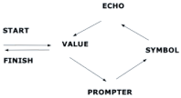
Select one or more:
a. Graph of learning a programming language
b. A graph describing the error prevention
c. User interaction cycle associated to an edit box 
d. User interaction cycle associated to radio buttons  Your answer is correct.
The following figure describes graphically the following gesture as a user input technique:
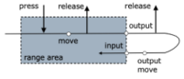
Select one:
a. Range gesture 
b. Press-timer gesture
c. Drag gesture
d. Click gesture
Your answer is correct.
_{◄ Announcements Jump to...}Task-Centered User Interface Design ►
https://moodle3.cs.utcluj.ro/mod/quiz/review.php?attempt=63565&cmid=22729 13/13

